CMPE314

Fall 2018

Lab Project: AM Radio Receiver

Hamza Mahmood

Josh Bastian

Section: 01 TH 9:00-11:00 AM

Rui Jin

**Purpose:**

The Purpose of this is lab is to design, implement and demo a simple AM radio receiver circuit. Using our knowledge of current and voltage game circuits like the common emitter and emitter follower we must construct a circuit that will have the necessry radio frequency amplifier and audio signal amplifier that will be able to pick an AM frequency.

**Equipment:**

Voltage Supply

Antenna

Approximate Resistors (15330(2),10k(2),220(2),1550(2)

Capacitors(.1u,100u,22u(2)

Transistors (2)

Radio Amplifier Kit

Headphones

F gen Supply

Multimeter(just in case)

**Procedure:**

1. Theoretically Simulate and design and calculate you Pre Amp Stage using the circuit below
2. Build the circuit and supply a 2mv sinusoidal input (use resistors to reduce voltage input) and apply a 9v input.
3. Plot out results of the gain from the Collector Resister and look for a gain of more than 400.
4. Then build and connect the audio amplifier the (emitter follower circuit) and connect a headphone
5. Finally connect your circuit to the radio am kid in the right spots and tune till you pick up a radio frequency from the speaker

**Measure Data:**

Measured Data in the Following Experiment are the Resistor and Capacitor Values chosen for the Circuit:

**Common Emitter Circuit**

R1- 15330 Ω

Rc1- 10k Ω

Re1-220 Ω

R2- 1550 Ω

Rc2-10k Ω

Re2-220 Ω

C1 - .1u

C2- 100u

Bypass Capacitors- 22u

**Emitter Follower**

R1 – 22k

R2 – 47k

Re – 100Ω

C1- 100u

Bypass Capacitor – 220u

**Graphs and Design:**

**-Pre Amp Stage Graph and Designs**

Pre Amp Circuit 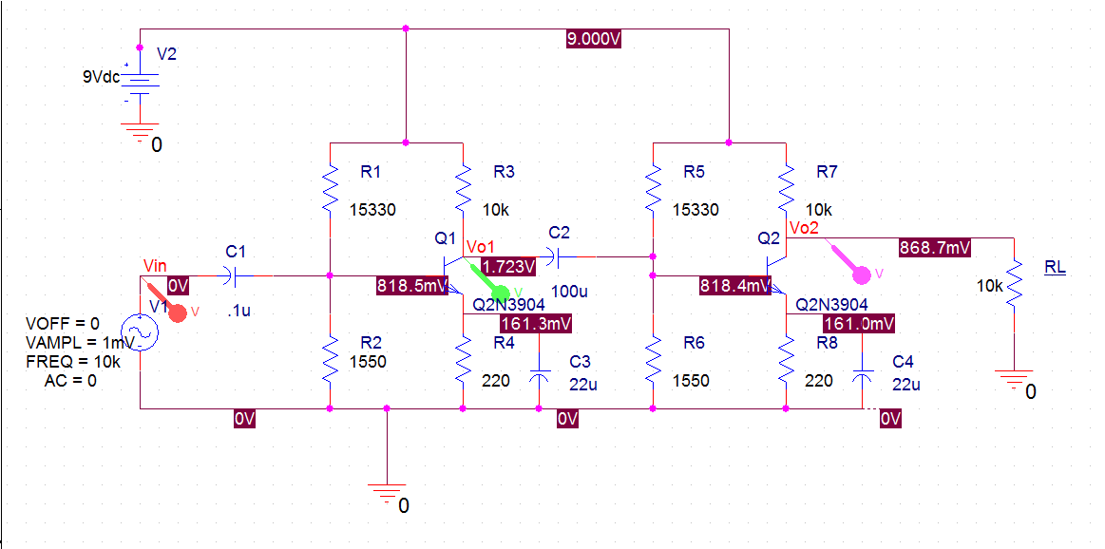

Second Circuit

Graph from Simulation on Cadence of the Voltage of Input vs Voltage Output and Voltage Output of the first Common Emitter

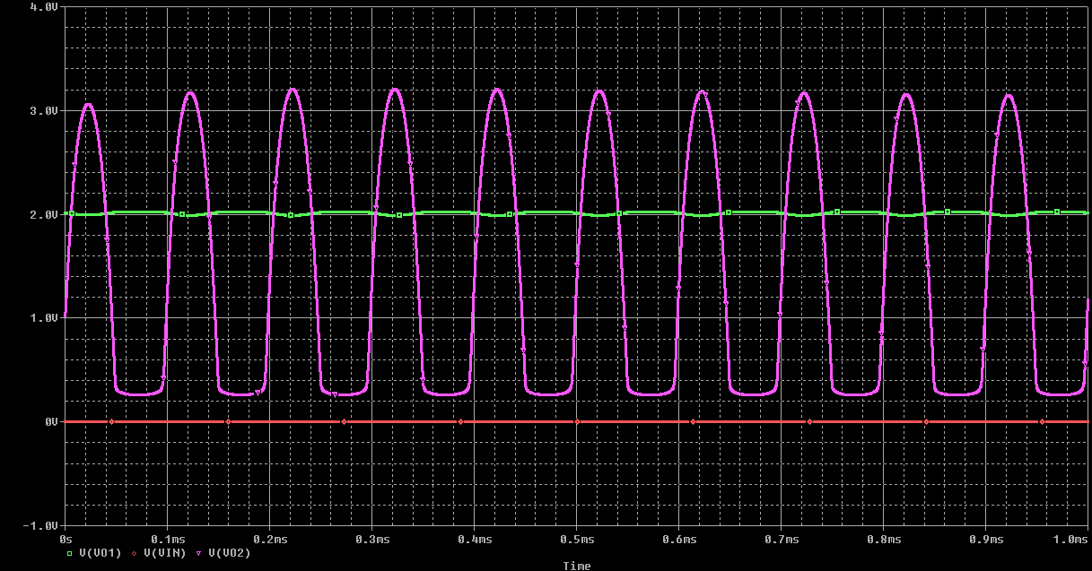

-Red Line is the Vinput Green Line is Voltage Output of the first Common Emitter and Purple Line is the Voltage Output of the of the Overall Circuit

Graph of Real Simulation of Vin vs Vo

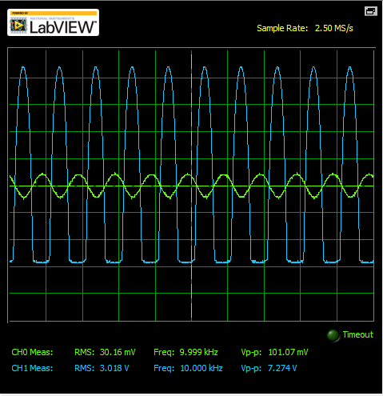

**-**

**Final Stage Audio Amplifier and Calculations**

Emitter Follower Circuit(Audio Amplifier)

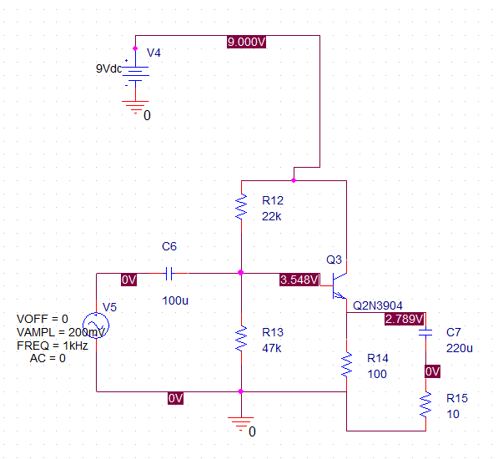

Graph of Emitter Follower from Cadence Simulation Vin vs Vo

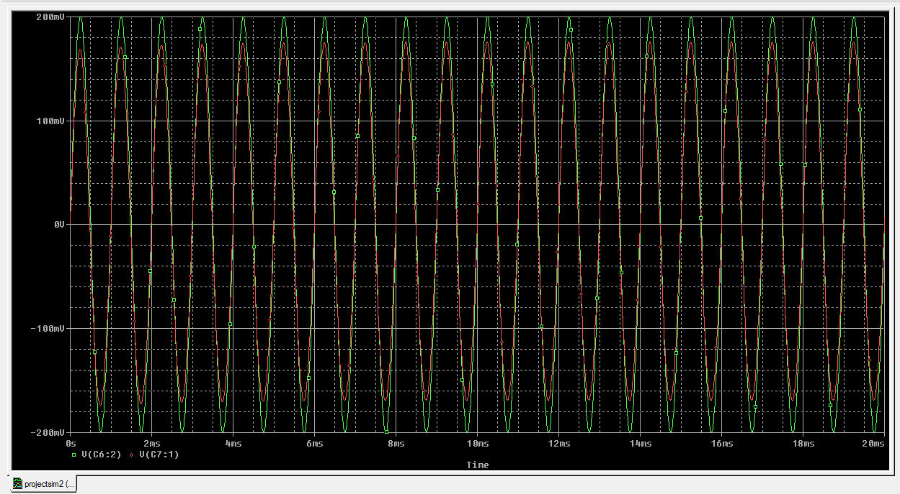

Graph of Emitter Follower from Real Simulation Vin vs Vo

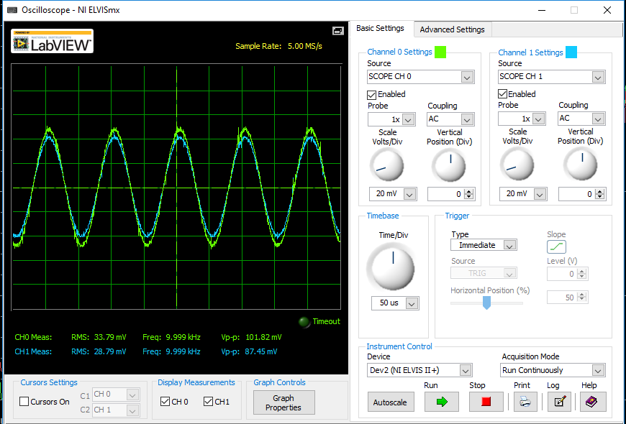

**Calculations:**

**\*Calculations were done in Matlab and below are the scripts**

**Common Emitter Calculations**

Rc = 10000; **//Set Value to find Re**

Av = 30;

B = 168;

Vcc = 9;

Vce = 4.5;

Vt = 0.026;

syms Rc

eqnRe = ((-B*Rc)/Av)-((Vt*B)/((Vcc -Vce)/(Rc+(((B+1)/B)*Re))))*(1/1+B) == Re;

solb2 = solve(eqn,Re)**//Equation is solving the Re value**

R2 = 1000;

syms R1

eqnR1 = ((Vcc*(R2/(R1+R2)))-0.7)/(((R1*R2)/(R1+R2))+((1+B)*311.07)) == 2.597*(10^-6)

solb3 = solve(eqn1,R1)**//Equation is solving for the R1 Value**

**Emitter Follower Calculations**

**//Set Values**

Ro = 200;

Rs = 10;

B = 168;

Rpi = 33790;

Vt = 0.026;

Vcc = 9;

Vbe = 0.7;

eqn = (Rpi+Rs)/(1+B) == Ro;

%solb = solve(eqn,Rpi); **//Equation Solves for Rpi**

Icq = (B*Vt)/Rpi;

Re = 100;

Re = (Vt-Vceq)/Ieq;

R1 = 22000;

Rth= (0.1)*(1+B)*Re;

syms R2

eqn4 = (1/R1)*((0.1)*(1+B)*Re) == (R2/(R1+R2));

solb3 = solve(eqn4,R2) **//Equation Solves for R2**

Vth = (1/R1)*((0.1)*(1+B)*Re)*Vcc;

syms R1

eqn3=B*((((1/R1)*((0.1)*(1+B)*Re)*Vcc)-Vbe)/(((0.1)*(1+B)*Re) +(1+B)*Re))== 1.2927e04;

%solb2 = solve(eqn3,R1) **//Equation solves for R1**

%Results from the equations

Rpi = 33790

Icq = 1.2927e-04

**Capacitor Values Calculations**

Voltage Transfer Function:

$${{(R}_{p})}/{{(Rs}_{}+Rp)* \frac{1}{1+\frac{R_{p}}{{(Rs}_{}+Rp)}*\frac{Cp}{Cs}+\frac{1}{τ_{s}}+sτ_{p} }}$$

$τ_{s}=\left(Rs+Rp\right)C$ and $τ_{p}=(Rs ||Rp)Cp$

When Cp << Cs the transfer function becomes = $\frac{R_{p}}{{(Rs}_{}+Rp)}* \frac{1}{1+\frac{1}{sτ_{s}}+sτ_{p}}$

Proving the circuit is a band pass circuit

Common Emitter Circuit 1 Input Capacitor: $C_{E1}= \frac{1}{2π\left(R_{1 }\right||R_{2)}f_{min}}= .1uF$

First Common Emitter:

$C_{P1}= \frac{1}{2πR_{E1}f}=22mF$

Common Emitter Circuit 2 input Capacitor: $C_{E2}= \frac{1}{2π\left(R_{1 }\right||R_{2}+R_{o1})f}= 100uF$

Second Common Emitter:

$C_{P2}= \frac{1}{2πR_{E2}f}=22mF$

**Conclusion:**

The design of our radio in the end worked and was able to pick up frequencies. The most difficult part of the project was getting the Voltage gain we needed of greater than 400. Our calculations enabled us to get the right resistor values but when it came to testing the theoretical and experimental simulations weren’t matching. Trial and Error with the capacitor values led us to the right voltage gain we needed. The Pre Amp Stage led us to understand the common emitter circuit and what is truly necessary for a voltage gain. An essential part to our design was the coupling capacitors on the emitter resistors, they made a huge gain in the frequency response of Vo . To make that gain of over 400 we connected to two common emitter circuits in series with a capacitor making sure we had a gain of 30 in the first common emitter so when series connected it would just multiply. In the Audio Amplifier Stage with the Emitter Follower we were able to observe the relationship of keeping the voltage almost the same. This experiment demonstrates how a radio receiver works in the real world and how radios can pick up these frequencies.